Title | Software Subsystem Design Description <Front-end Interface Subsystem>
Distribution | Software Archive
Author | Zuochen Wang | Date | 2014-01-08
Review | See review section | Date | See review section
Approved |  | Date
Remarks

Contents
1 Context 3
1.1 Overview 3
1.2 Use Case Diagram 3
1.3 Subsystem Definitions 4
1.4 Acronyms and Abbreviations 4
2 Data Sheet 4
3 Detailed Description 6
3.1 Static Modelling 6
3.2 Dynamic Modelling 6
3.3 Class Design 8
3.4 Detailed Design 9
3.4.1 FEI communication protocol 9
3.4.2 Buffer mechanism 9
3.4.3 Application Interface method 10
3.4.4 Layer7 method 11
3.4.5 Layer2 method 11
3.4.6 FEI alarm 12
3.5 Safety Design 12
3.5.1 Information redundancy 12
3.5.2 Transmission redundancy 13
3.5.3 Interrupt 13
3.6 Design Decisions and Limitations 13
3.7 Hardware Dependencies 13
3.8 Data Object Description 14
4 Design Review 14
4.1 Review Participants 14
4.2 Decision of the Review 14
4.3 Check List 14
4.4 Defect 15
References 15
Revision History 15

List of Figures

Figure 1: Use Case Diagram of FEI Subsystem 3
Figure 2: Context Diagram for FEI Subsystem 6
Figure 3: Collaboration diagram of Front-end Interface subsystem 7
Figure 4 State diagram of data transmission (Master CB) 8
Figure 5 Flow chart diagram of buffer and counter semaphore Error! Bookmark not defined.
Figure 6: FEI subsystem class diagram 9

List of Tables

Table 1. Failure analysis on interrupts 13
Table 2: Data Objects Table 14

Context

This document is a representation of analysis, planning, implementation and decision-making for the VT5 project’s Front-end Interface subsystem. One of its major goals is to support reuse of the described subsystem.

Overview
This document describes the functional design specification for the Front-end Interface subsystem of VT5(for reqiurements, see SSRS_Software Subsystem Requirement Specification FEI [2]).

The Front-end Interface subsystem realize the data transmission between FEB and CB through half-duplex UART hardware physical layer. It acts like a channel between two board.
The subsystems put the command request to the Front-end Interface subsystem, and the FEI subsystem will process the data transmission. The Front-end subsystem makes the communication safe and efficient.

Use Case Diagram
The following Use Case diagram illustrates the top-level uses derived in the Front-end Interface Subsystem Requirements Specification .

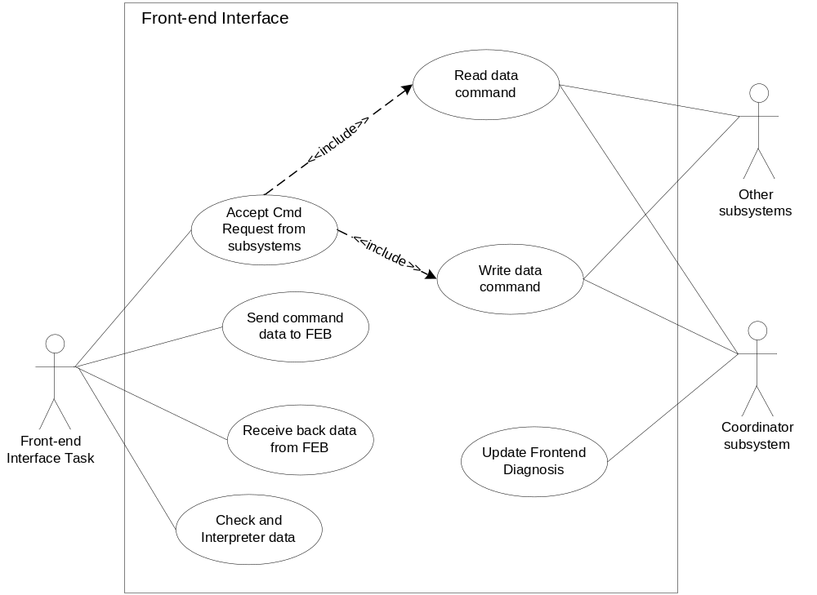
Figure 1: Use Case Diagram of FEI Subsystem

Subsystem Definitions

Diagnostic Subsystem | Subsystem responsible for handling error conditions and warnings. Also provides General Alarm data for the Digital Output subsystem.
Digital Output Subsystem | Subsystem for providing output signals (eg: for pulse output or logic output) to external hardware.
PA/FF Subsystem | Subsystem for interfacing to Profibus PA / Foundation Fieldbus
HART Subsystem | Subsystem for interfacing to HART (Highway Addressable Remote Transducer) protocol communications.
HMI Subsystem | Subsystem providing Human Machine Interface for local user access via display and key input.
NV Subsystem | Subsystem responsible for read / write access and maintenance of non-volatile memories (in transmitter and sensor).
MVM Subsystem | Subsystem for providing Multi-Variable Measurement
SVM Subsystem | Subsystem for providing Single Variable Measurement
Totalizer Subsystem | Subsystem for totalizing the device variable value like volume or mass flow etc.
Mapper Subsystem | Subsystem for mapping the device variable to HART dynamic variable
UOM Subsystem | Subsystem for providing unit conversion
Electronic Service Subsystem | Subsystem for providing ram/rom check, temperature/ push_button check.
Measurement | Measurement is the generic name of all device variables includes temperature.

Acronyms and Abbreviations

Term | Definition
CB | Communication board
FE/FEB | Front-end Board
HW | Hardware
N/A | Not Applicable
NV | Non-volatile
TBD | To Be Determined
CRC check | Cyclical Redundancy Checking
Frame number check | Every master request frame will generate an unique frame number, the slave response frame will return back this frame number. The master will check the consistency of the request and reply frame number.
Front-end busy | Front-end may be in busy state and refuse to accept CB command request.

Data Sheet
This chapter gives an overview about all important facts of the subsystem. It can be used by a developer who would like to reuse this subsystem.

Category | Item | Description
Development | Version / Status | Release
Development | Known Bugs | Not known ―― None
Development | Planned Improvements | None
HW-Platform | Type | M16C63 R5F363AM
HW-Platform | Clock | Oscillation clocking 3.6864MHz  CPU clocking 1.8432MHz
SW-Development Environment | Compiler | IAR M16C 3.40
SW-Development Environment | Operating System | Segger embOS for M16C version 3.28g
SW-Development Environment | Case / Code-Generation Tool | EntryTool 1.1.3
Required Resources | Operating System | Event
Required Resources | HW | UART 6  Timer A3  Interrupt: UART6_RX, UART6_TX, TMR_A3  Hand Shake pin: PD7.3  Reset pin 1: P7.2  Resetpin 2: P1.0
Required Resources | RAM | OvertimeCnt  CRCerrCnt  RetryTimes  feOldDiagnosis  T_FED_FRAME_TX_BUFFER uTransmitBuffer_FED_layer7  T_FED_FRAME_RX_BUFFER uReceiveBuffer_FED_layer7  mReceiverBuffer  mSendBuffer  mBufferIndex  mBufferSendIndex  FrameNum  mMasterStatus  Comerr
Required Resources | NVRAM (Plant) | NA
Required Resources | ROM | NA
Required Resources | Execution Time | Execute when buffer is not empty.
Required Resources | Subsystems | 1.All the subsystem need to exchange data with FEB  2. Diagnosis subsystem
Required Resources | Data Objects | T_DIAGNOSIS_ALARM.  Detail objects please refer to 3.8
Standards | Safety | Communication safety—  Data frame include CRC checksum and frame number check. When transmission failure, CB will retry the transmission for 3 times.
Standards | Other | None
Documentation | Requirements / Use Cases | Please refer to USE CASE
Documentation | Public Interface Description | Please refer to Application Programmer Interface
Documentation | Test Specification | See [TP014]

Detailed Description

Static Modelling

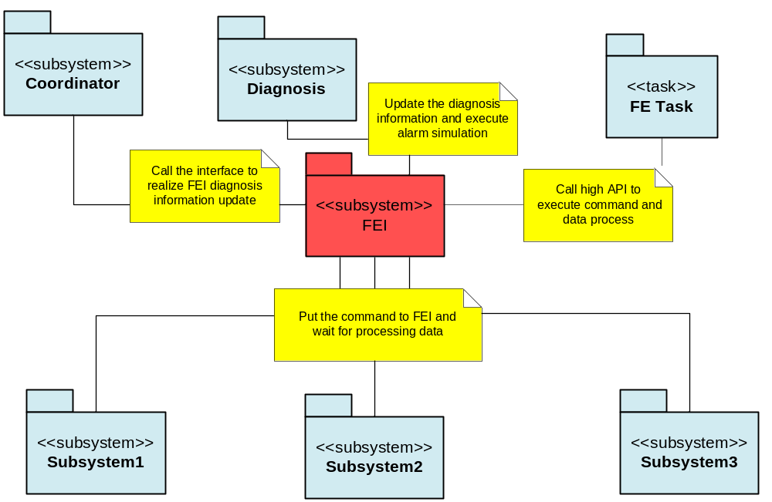
Figure 2: Context Diagram for FEI Subsystem

Dynamic Modelling

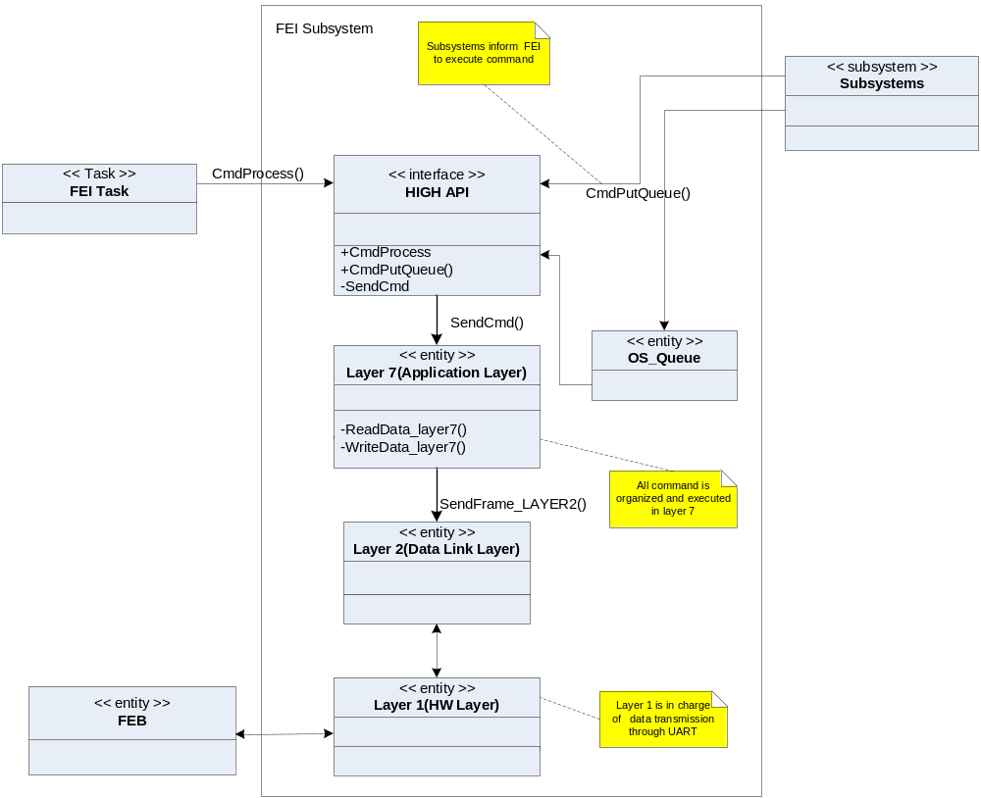
Figure 3: Collaboration diagram of Front-end Interface subsystem

This collaboration diagram represents the collaboration relationship between parts of FEI subsystem and how the FEI Task and Other subsystem collaborate with FEI subsystem
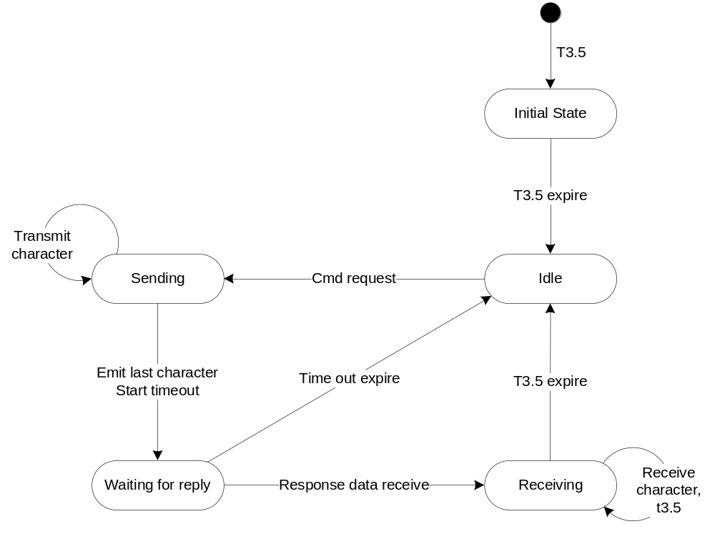
Figure 4 State diagram of data transmission (Master CB)

This state diagram shows the device state change when data receives and data transmits.

The Front-end task detect the buffer, if the buffer is not empty, then the task will send the message request and receive the FEB reply data. When the communication is finished, the task then will judge the communication status and check the data. When the communication status is ComOK(including the data correct), or the error times overceeds the MAX_RETRY times, clear this Buffer content, and deal with next buffer item. If the communication is ComFail or data checking fails, and the error times is not more than MAX_RETRY times, then the task will go back to the buffer entry, to deal with the same buffer content until this content is cleared.
The counter semaphore is used as the communication finishing flag, informing frontend task to go on interpreter the data frame received or go back to buffer entry.

Class Design
The object-oriented design approach implies that object method calls include the address of the object’s data structure. This has not been shown in the diagrams although the C implementation requires the address to be supplied manually. The parameter for this is referred to as the “me” pointer.
eg
TUSIGN16 Get_T_UNIT (const T_UNIT SLOW *me, TUSIGN16 objectIndex,
TINT16 attributeIndex, void FAST *ptrValue);
TUSIGN16 Put_T_UNIT (const T_UNIT SLOW *me, TUSIGN16 objectIndex,
TINT16 attributeIndex, void FAST *ptrValue);

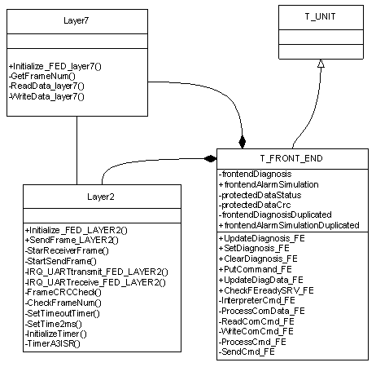
Figure 5: FEI subsystem class diagram

Detailed Design

FEI communication protocol
See FE and CB Communication Protocol [4].

Buffer mechanism

Buffer structure
Define Buffer Structure:
typedef struct
{
TUSIGN8 putIndex;
TUSIGN8 purgeIndex;
TUSIGN8 size;
CMD_MSG memBuf[MAX_Q_SIZE];
}Buffer_STRUCT;

Define Message Data type:
typedef struct
{
TUSIGN8 cmd;
TUSIGN8 datalen;
void (*procData)(TUSIGN8 length,TUSIGN8* const pDataBuf);
void (*setFlag)(TUSIGN8 flag);
TUSIGN16 crc;
}CMD_MSG;

Buffer method
void InitFEBuffer()
Initializes buffer.

TINT16 WriteFEBuffer(const CMD_MSG* cmdMsg)
Write a new message to buffer.

TINT16 ReadFEBuffer(CMD_MSG* cmdMsg)
Get a message from buffer.

TINT16 ClearFEBuffer(void)
Deletes the last retrieved message in a buffer.

TUSIGN8 IsFEBuferEnpty()
Query if the buffer is enpty.

Application Interface method

Put Buffer interface method
Name: TINT16 PutCommand_FE(TUSIGN8 cmdnum, TUSIGN8 datalen, void (*pFunc)(TUSIGN8 length, TUSIGN8* const pDataBuf))
Parameter:
cmdnum: the command number
Datalen: the data length copy from/to
pFunc: the method pointer that process the data
Return Value:
0: success;
1: buffer is full

The subsystem exchanged data with FEB, will use this interface to put a message into buffer, in order to inform the frontend task process the command request.

Command Process method
Name: void ProcessCmd_FE(void)
Shall called by FE Task.The method will keep checking the buffer, if the buffer is not empty, it will process the command sending and data interpreter.

Data Interpreter method
Name: void InterpreterCmd_FE (const CMD_MSG* pMessage)
Param:
pMessage: the point of the buffer message

This method will check the communication status and the correction of reply data, first use the frame number check, then use the CRC check to make sure the reply data is OK. Then use ComDataProcess() method to process the right data. The method also manage the retry time and overtime counter.

Communication Data process method
Name: void ProcessComData_FE (const CMD_MSG* pMessage)
param:
pMessage: the point of the buffer message

This method will process the data from receiving buffer according to the command type.

Send command method
Name: void SendCmd_FE(const CMD_MSG* pMessage)
Param:
pMessage: the point of the buffer message

The method will interpret the command and informs layer7 to process the command.

Check DataCrc method
Name: void CheckDataCrc_FE(void)

This method will check the reply data CRC of the subsystem protected data.

Update Diagnosis method
Name: void UpdateDiagnosis_FE(void)

This method will inform the diagnosis about the FEI alarm information, including the communication error and FEB error which is transferred by certain command from FEB.

Layer7 method

Create Frame number method
Name: TUSIGN8 GetFrameNum(void)
Return Value: The frame number

This method will generate the frame number which will be used as one of the check method.

Read data method
Name: void ReadData_layer7(const CMD_MSG* pMessage)
Param: pMessage: the pointer of buffer cmd message

This method is the common read data method to get data from FEB.

Write data method
Name: void WriteData_layer7(const CMD_MSG* pMessage)
Param: pMessage: the pointer of buffer cmd message

This method is the common write data method to get data from FEB.

Layer2 method

Initialize method
Name: void Initialize_FED_LAYER2(void)

This method is to initialize FEI layer2.

Send frame method
Name: void SendFrame_LAYER2(void)

This method is to prepare for sending data, including the CRC checksum calculation and inform hardware layer to do the sending action.

Start receive data method
Name: void StarReceiverFrame(void)

This method is to prepare for data receiving.

Check frame number method
Name: TUSIGN8 CheckFrameNum(void)

This method is to check the received frame number of the received data frame.

Check CRC method
Name: TUSIGN8 FrameCRCCheck(void)

This method is to check the received frame CRC checksum.

FEI alarm

The FEI subsystem only has one alarm --- FEI communication error.
This error includes response time over error, CRC check error, frame number error, FE response message error.
The coordinator subsystem will inform the diagnosis subsystem this alarm by the interface UpdateDiagnosis_FE( );
If the FEI communication error exceeds the MAXERRORCNT, the FEI subsystem will reset the FE board by repower it.

Safety Design

Information redundancy
The transmission data use CRC checksum, which is re-calculated by receiver, in order to ensure data correction. If the calculated CRC checksum is not the same with the received CRC checksum, the frame is considered as a failure frame.

In every request frame, there is a unique frame number generated by CB, the FEB received the frame and send back the frame number. CB will compare this back frame number with the sent frame number, if they are not the same; consider this response frame is not correct.

Transmission redundancy
When communication (CRC error, frame number error and timeout) error occurs, CB will retry this command again. The maximum retry times are 3. If after 3 times retry, there is still error existing, the CB will inform the diagnosis subsystem about this communication error.

Interrupt
Table 1. Failure analysis on interrupts
Interrupt | Failure mode | Applied measures
Timer A3 interrupt | No interrupt creation | CB can’t get frames from FE. CB will show communication error and go to safety state.
Timer A3 interrupt | Interrupt stop | CB can’t get frames from FE. CB will show communication error and go to safety state.
Timer A3 interrupt | Cross-over of interrupt implementation | - All unused peripherals and interrupts are disabled.  - All received data are check by 16bit-CRC. If cross-over of interrupt happen, CB will detect the data integrity, show communication error and go to safety state.
Timer A3 interrupt | Continuous interrupt execution | - CB always responds to Timer A3 interrupt and can’t trigger software watchdog in time. CB will be reset and go to safety state.  - CB always responds to Timer A3 interrupt and fails to trigger hardware watchdog. CB will be reset by watchdog and go to safety state.
UART6 receive interrupt | No interrupt creation | CB can’t receive data from FE. CB will show communication error and go to safety state.
UART6 receive interrupt | Interrupt stop | CB can’t receive data from FE. CB will show communication error and go to safety state.
UART6 receive interrupt | Cross-over of interrupt implementation | - All unused peripherals and interrupts are disabled.  - All received data are check by 16bit-CRC. If cross-over of interrupt happen, CB will detect the data integrity, show communication error and go to safety state.
UART6 receive interrupt | Continuous interrupt execution | - CB always responds to UART6 interrupt and can’t trigger software watchdog in time. CB will be reset and go to safety state.  - CB always responds to UART6 interrupt and fails to trigger hardware watchdog. CB will be reset by watchdog and go to safety state.

Design Decisions and Limitations
The FEI Subsystem is designed based on ABB BUI Common Framework [1]. Use entry tool to generate all the public objects and methods.

Hardware Dependencies
The frontend interface subsystem is designed on the Renesas MCU16C63, using the resource UART6 and timer3A to realize the communication between CB and FEB.
UART6 is used for the serial communication, and the timer 3A is used for the communication status change and judgement.

Data Object Description
Table 2: Data Objects Table

Object name | T_DATA_OBJ | Data Class | Storage | Description
frontendDiagnosis | SIMPLE_U8 | DynamicDuplicated | RAM | Front-end Interface alarm information
frontendAlarmSimulation | T_DIAGNOSIS_ALARM | DynamicDuplicated | RAM | Front-end Interface alarm simulation object
frontendDiagnosisDuplicated | SIMPLE_U8 | DynamicDuplicated | RAM | Duplicated data object of frontendDiagnosis
frontendAlarmSimulationDuplicated | T_DIAGNOSIS_ALARM | DynamicDuplicated | RAM | Duplicated data object of frontendAlarmSimulation
protectedDataCrc | SIMPLE_U16 | protected | READONLY-RAM | The crc check data of all the unprotected dynamic data.
protectedDataStatus | TABENUM8 | protected | READONLY-RAM | Protected/unprotected

Design Review

Review Participants
Place | Dept. | Name
CNAUS | PAMP R&D | Lawrence Shi, Vincent Liu | 2013-04-28 rev0.1
CNAUS | PAMP R&D | Lawrence Shi, Vincent Liu | 2013-05-18 rev0.2
CNAUS | PAMP R&D | Merrick Huang | 2014-01-09 rev0.3

Decision of the Review
 | Decision | Next steps
○ | Inspection passed without restrictions | Phase finished
 | Inspection passed with restrictions | some changes must be done
❑ | Inspection not passed | Inspection must be repeated

Changes are proved: The Reviewer confirms that all changes are done:
proved Rev: | Date: | Reviewer:
0.2 | 2013-05-18 | Lawrence Shi, Vincent Liu

Changes are proved: The Reviewer confirms that all changes are done:
proved Rev: | Date: | Reviewer:
0.3 | 2014-01-09 | Merrick Huang

Check List
 |  | Yes | No
1. | Is the software architecture distinct and documented? | Y
2. | Fit the modules together? | Y
3. | Are complex algorithms/procedures explained? | Y
4. | Is a strategy for error handling designated? | Y
5. | Is the configuration management system well prepared? | Y
6. | Are all open issues transferred to the defects table? | Y

Defect
No. | Checkpoint | Description | Major defect | Done date
1 | 1.2 | Use case diagram ‘include arrow’direction is not proper | N | 2013-4-28
2 | 3.1 | Context diagram shall add FE task part. | N | 2013-4-28
3 | 3.3 | In the class diagram, the Generalization denotation is not proper | N | 2013-4-28
4 | 3.4.6 | Shall add the FEI alarm information | N | 2013-4-28

References
Ref. | Document
[1] | ABB BUI Common Framework release 2.3.1
[2] | [RS013] Software Subsystem Requirement Specification FEI
[3] | [DS002] VT5 FW Design Specification
[4] | [DS006] VT5 FE and CB Communication Protocol
[5] | Modbus_Application_Protocol_V1_1b
[6] | Modbus Over Serial Line V1.02
[7] | UM01001_embOS_Generic
Revision History
Rev. | Description of Version/Changes | Primary Author(s) | Date
0.1 | Initial revision. | Spring Kunli.Zhou | May19, 2012
0.2 | Modified after review by Lawrence and Vincent | Spring Kunli.Zhou | April 28, 2013
0.3 | Add interrupt safety analysis in section 3.5.3. | Zuochen Wang | 2014-01-09

